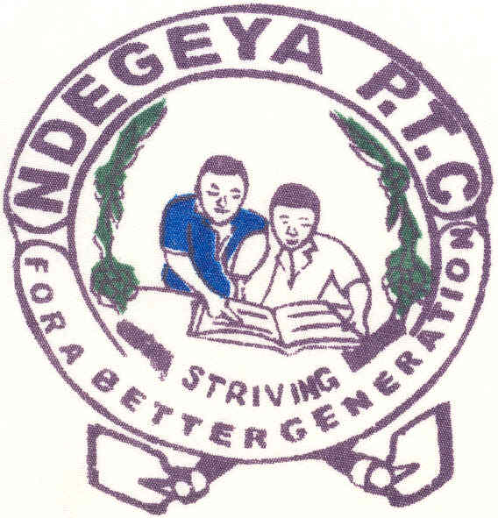 **NDEGEYA CORE PRIMARY TEACHERS’**

**COLLEGE – MASAKA**

P.O. Box 63,Masaka – UGANDA

Contacts: 0772669834, 0706554145, 0772579327, 0772515892

Our Ref: NDE//10/2022

Your Ref……………………….

**07/10/2022**

**TO ALL GRADE 111AND NURSERY TEACHERS.**

**The above Teachers who wish to upgrade for DEP and DEC by Kyambogo University should come and apply online at Ndegeya Core Primary Teachers’ College.**

**Diploma in Education Primary (DEP) Requirements**

* Non refundable application fee for Kyambogo University of shs: 50,000= excluding bank charges. You can pay using Visa Card/Direct to the Bank.
* The Uganda Certificate of Education (O’level) with a minimum of 5passes obtained at the same sitting ,Grade 111 Certificate/Competence test, Grade 111 result slip (not certificate)
* Should have passed Grade 111 certificate with a Distinction or Credit.
* Should have 2 years teaching experience.
* Should have a TMIS Registration Certificate
* Should have a National Identity Card.

**Diploma in Early Childhood Development (DEC**) **Requirements**

* The Uganda Certificate of Education (0’level) with a minimum of 5passes obtained at the same sitting ,Grade 11 Certificate/Competence test, Grade 11 result slip (not certificate
* Should have a certificate in Early Childhood Development with a Distinction of Credit from an Accredited Institution.
* Should have 2 years teaching experience.
* Should have TMIS Registration Certificate.
* Should have a National Identity Card.

**OR:** Those who specialized in ECE at Grade 111can also apply for DEC. Should have an original certified Academic Transcript/Result slip and Grade 111 Teachers’ Certificate.

**Any other information contact the following:**

**ICT Instructor: 0782970714/0703823060**

**Secretary: 0788596033/0752328040**

**DPP: 0772579327/0752579327**

**MANAGEMENT**